Building a Weather program

Using curl command

*man curl*

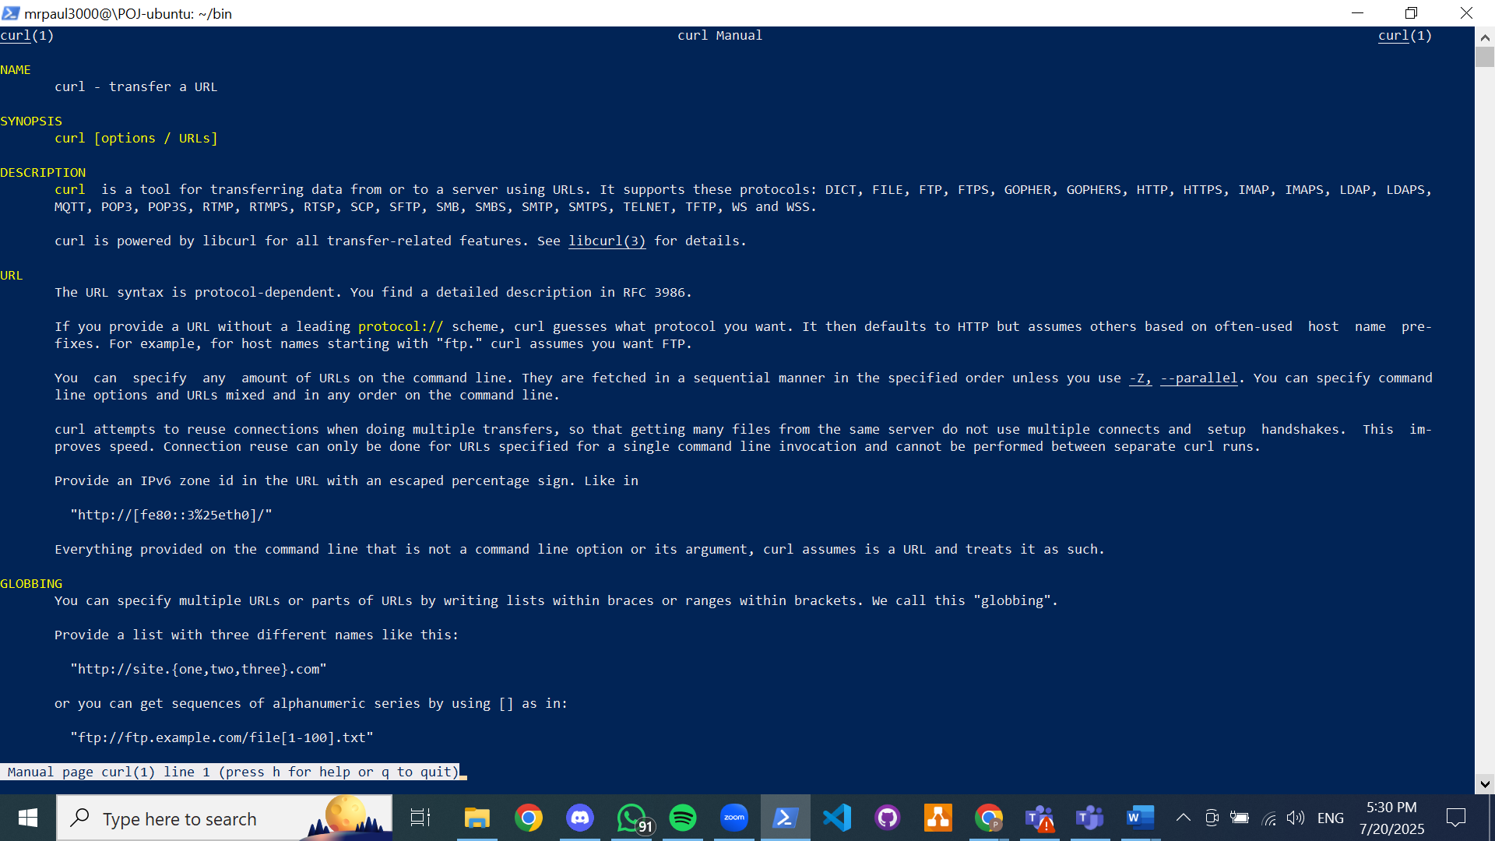

Using *curl wttr.in* command; this executes weather api; this provides the weather report of current location +/-1 day

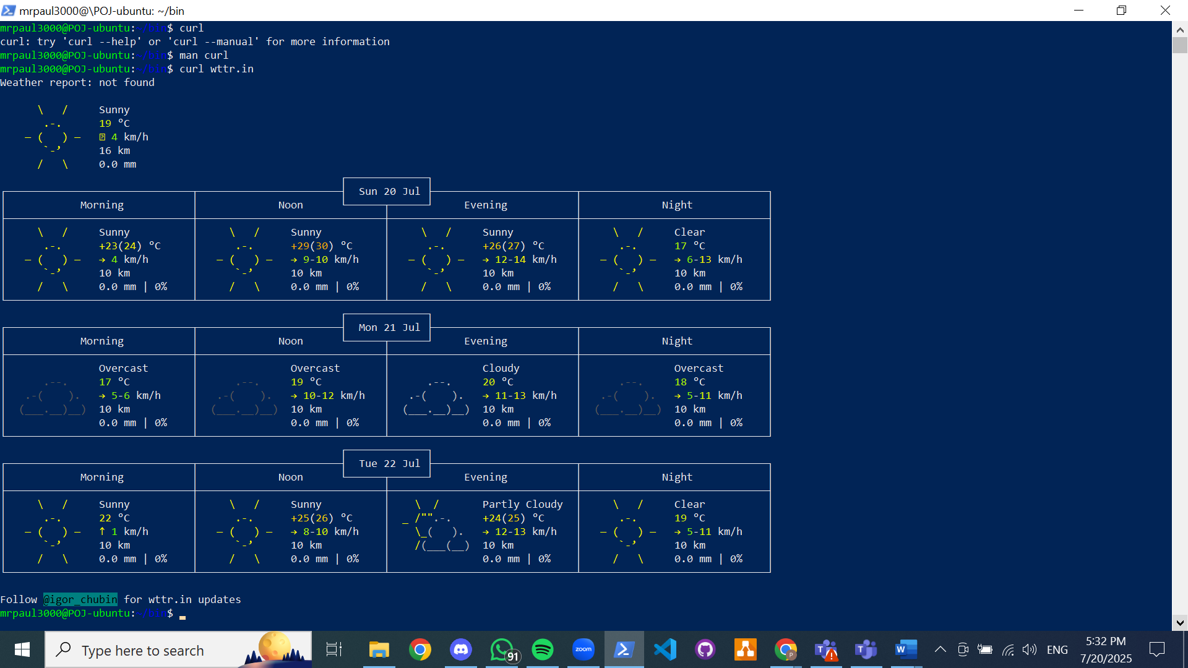

Running command to check weather in lagos

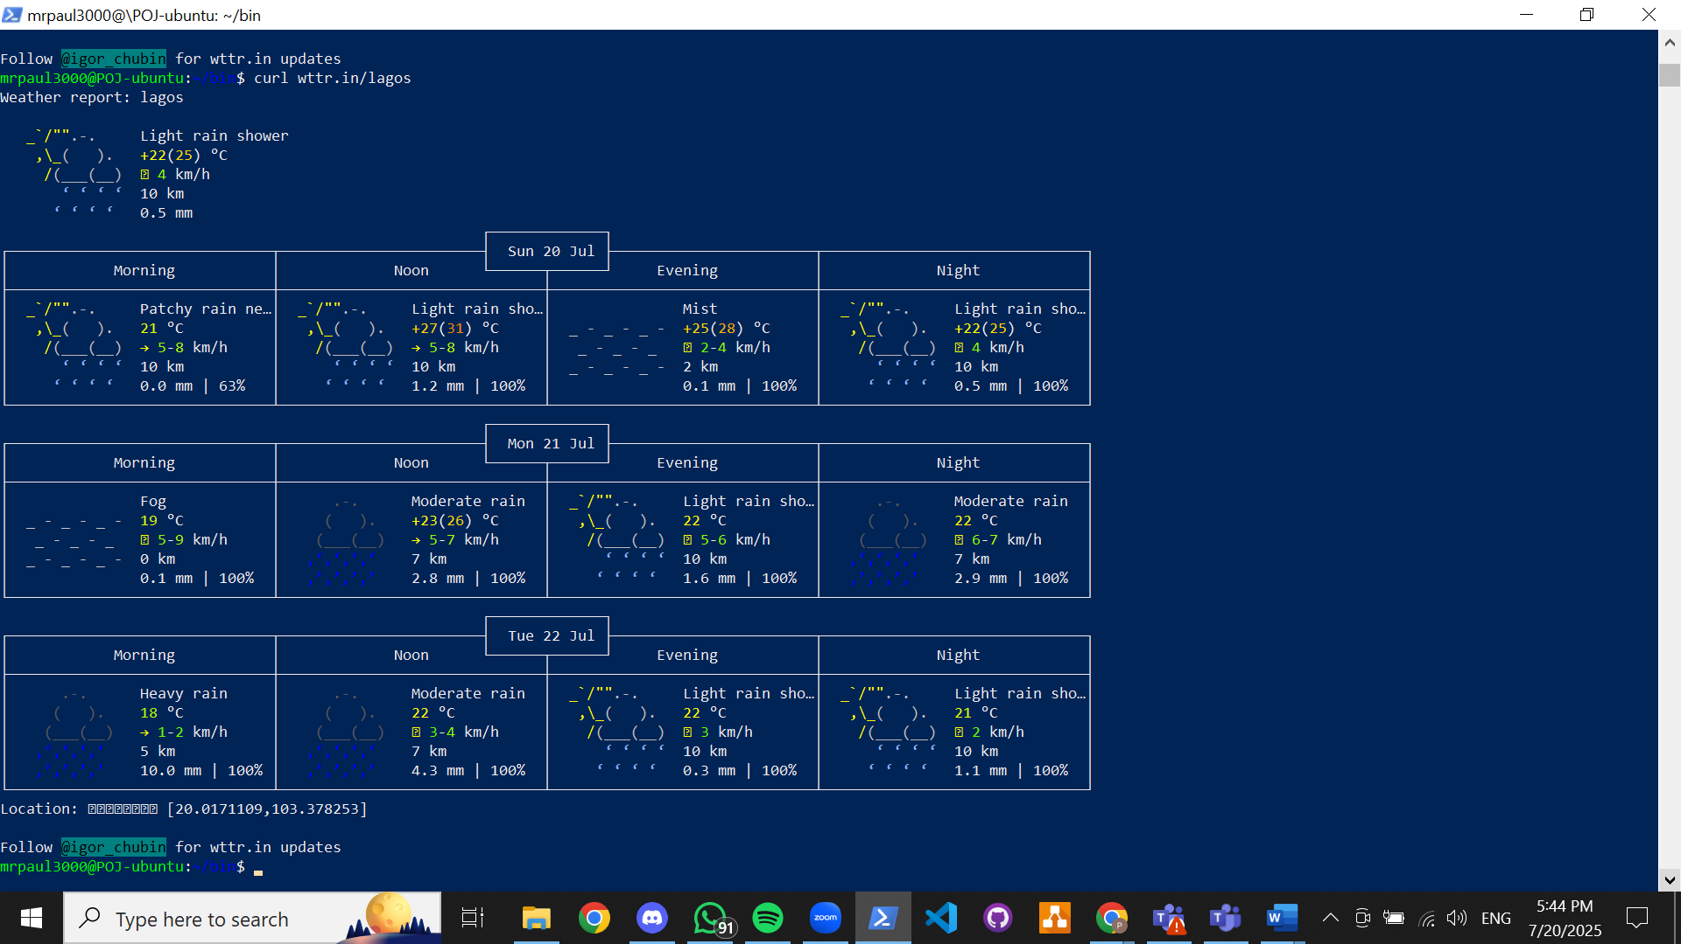

…london

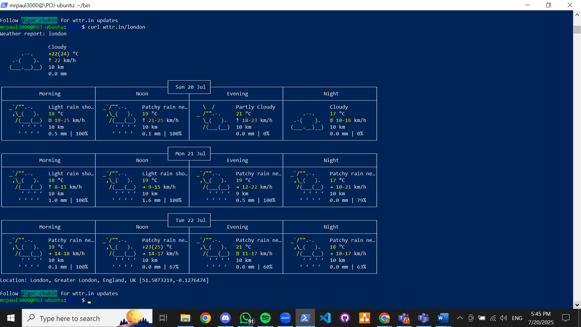

Writing script to run weather command;

* Creating the weather script with bash command, giving permission to execute and executing simple weather script

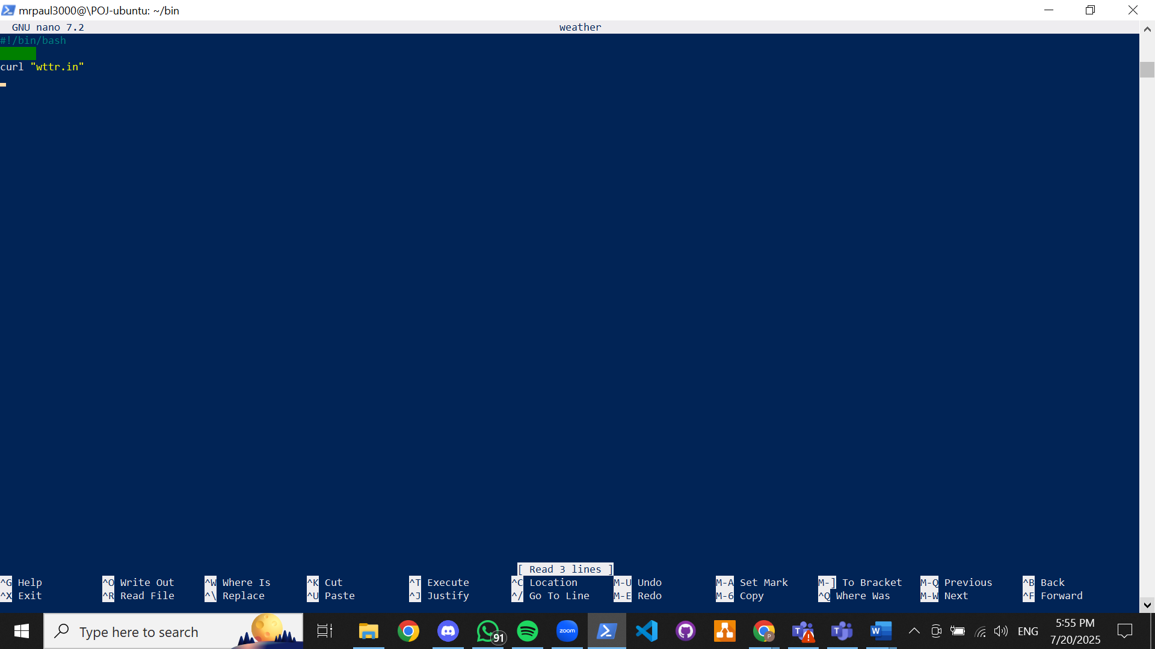

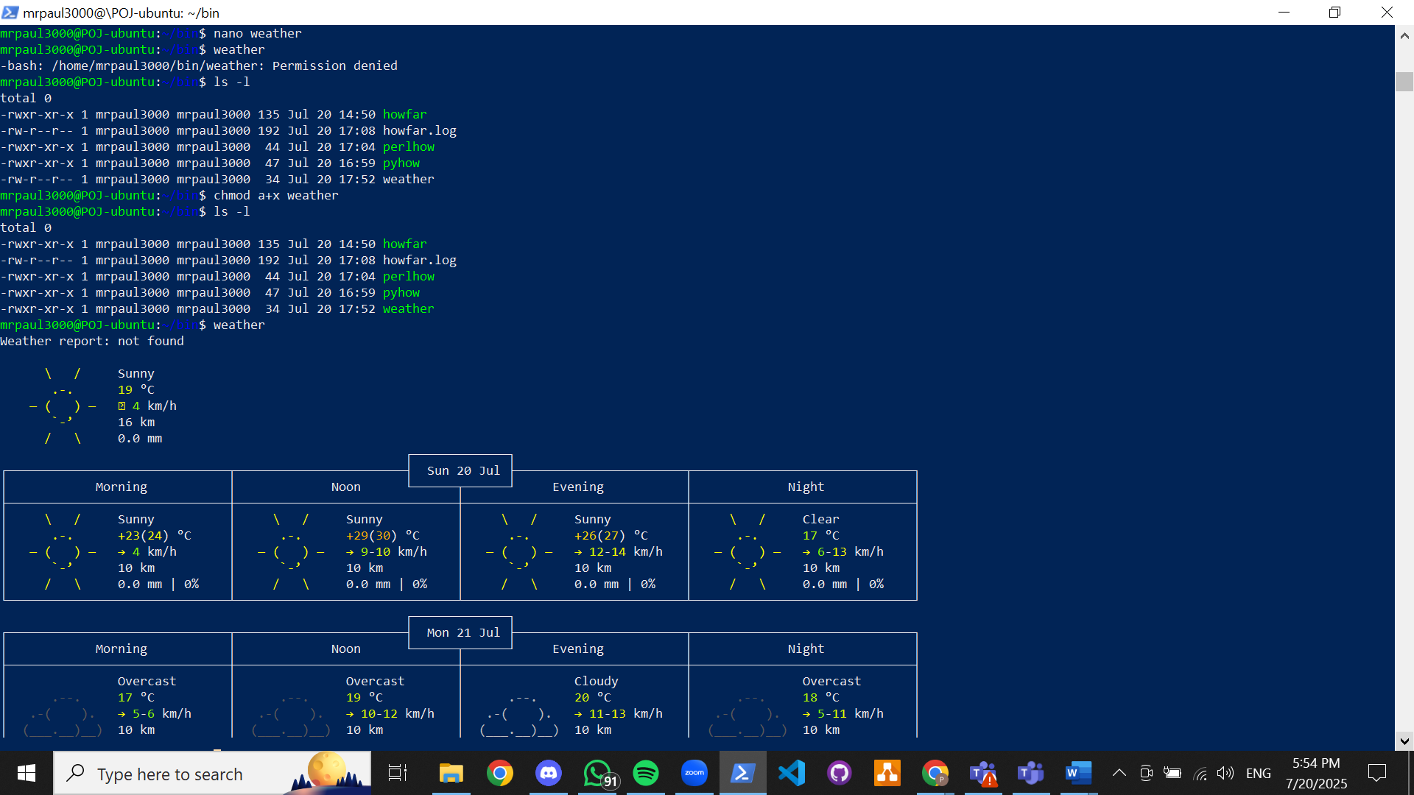

Editing the bash script to add more commands

* Using $1 to call first value in a command, $2 for second and so on
* This can be edited into the bash script to print commands in order of the position of its value when the bash script is run

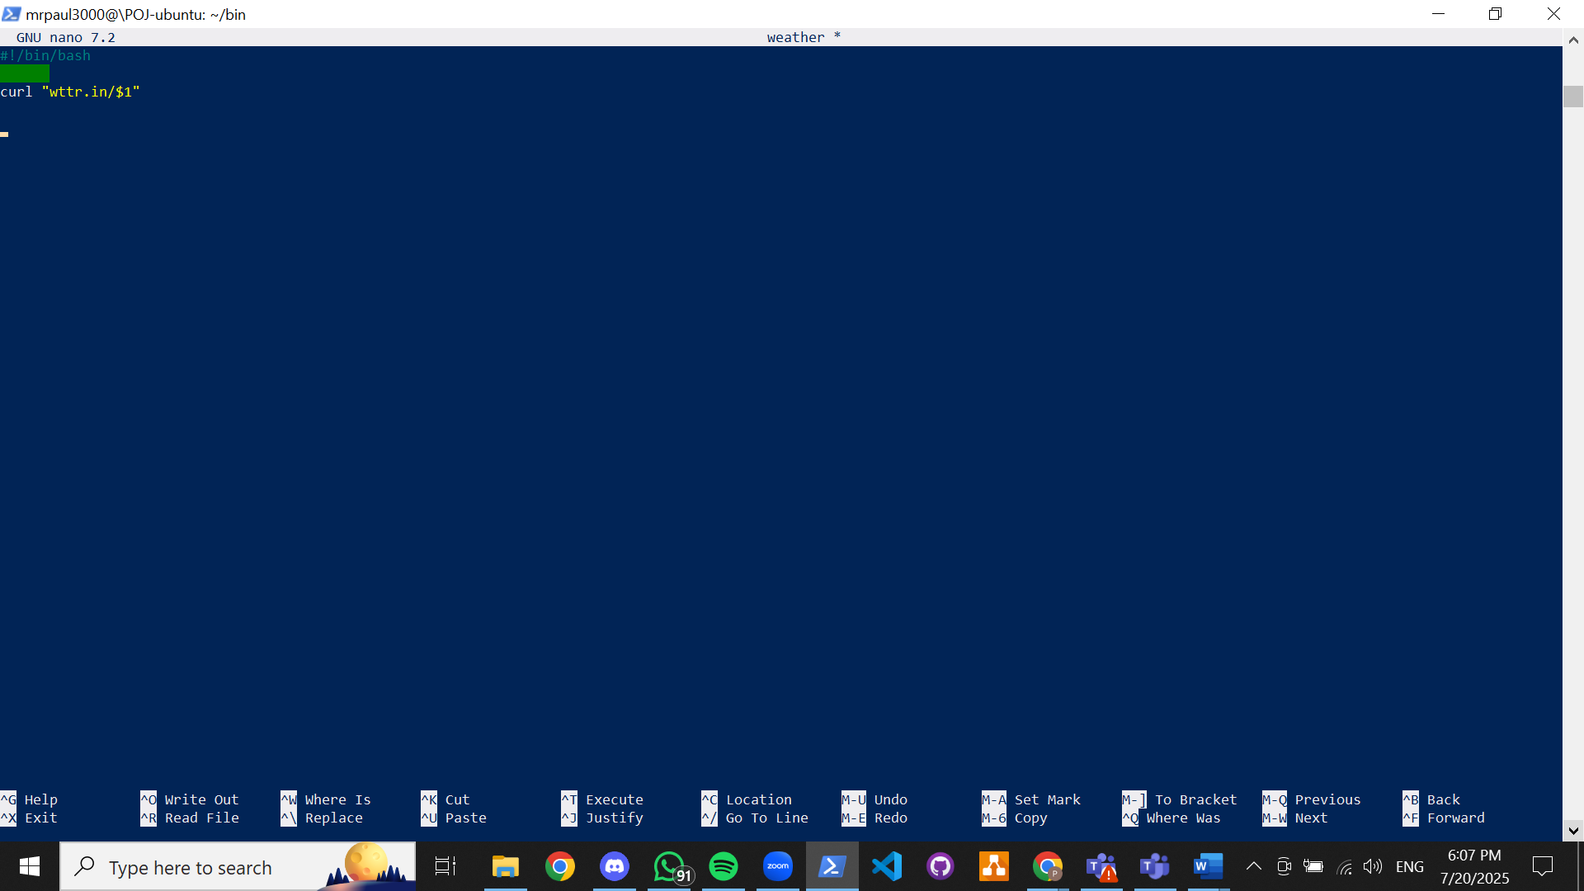

First value of command >> Paris

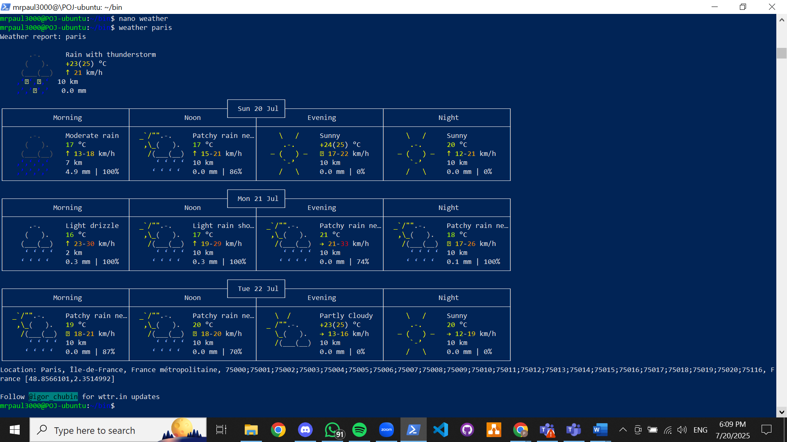

First value of command >> (nothing) ; with $1 = 0, script will run *wttr.in* command only (in this scenario, location will default current location)

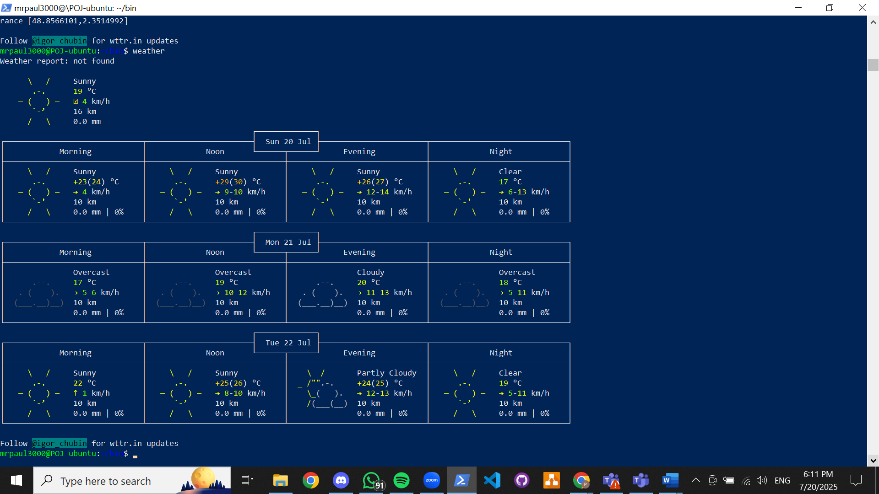

Using *case* to create options for $1 in bash script;

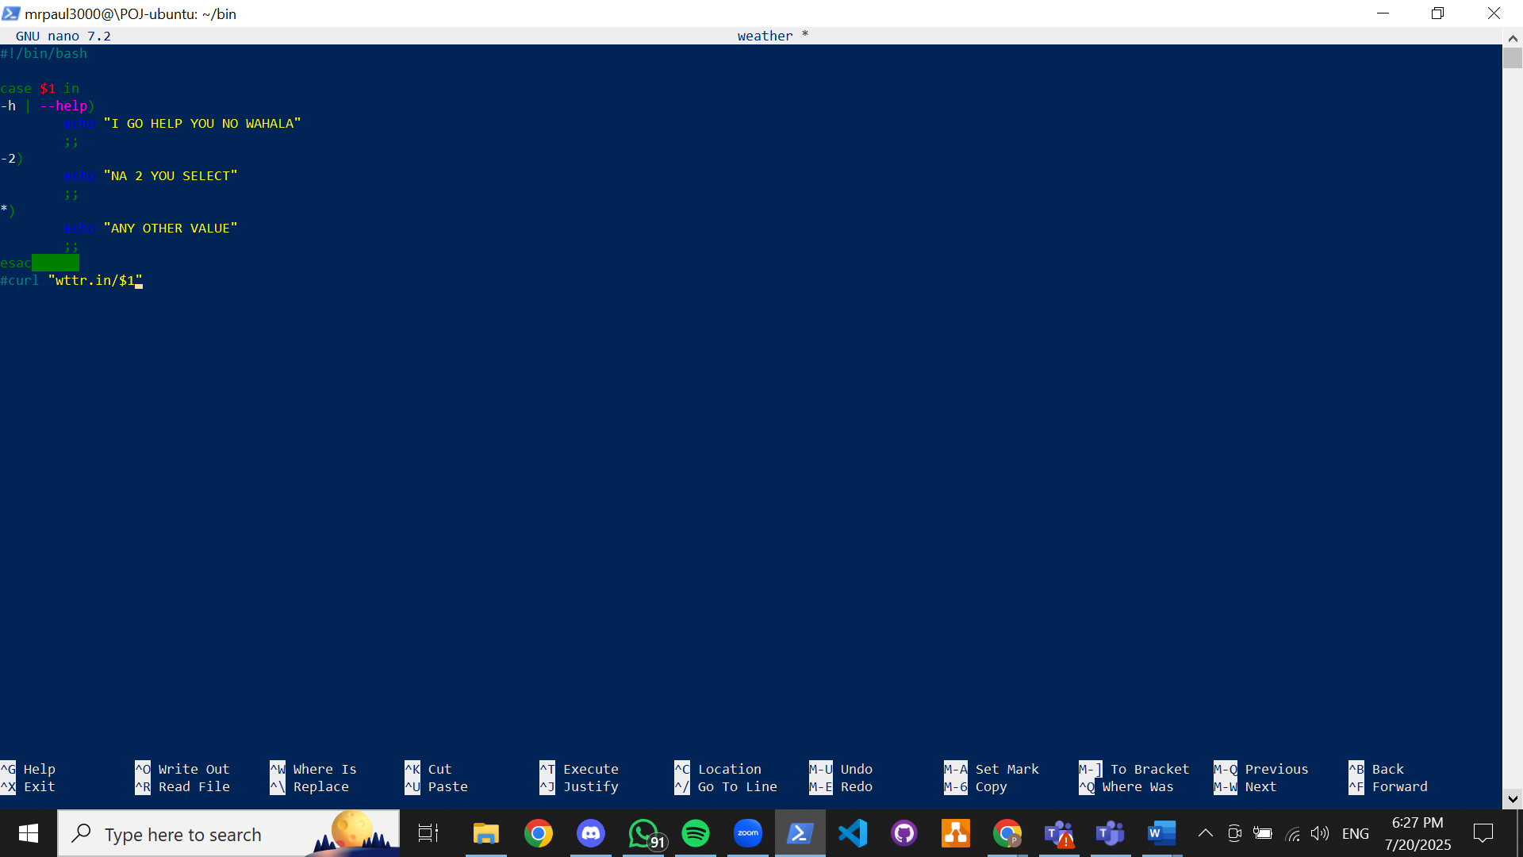

executing commands to run scripts

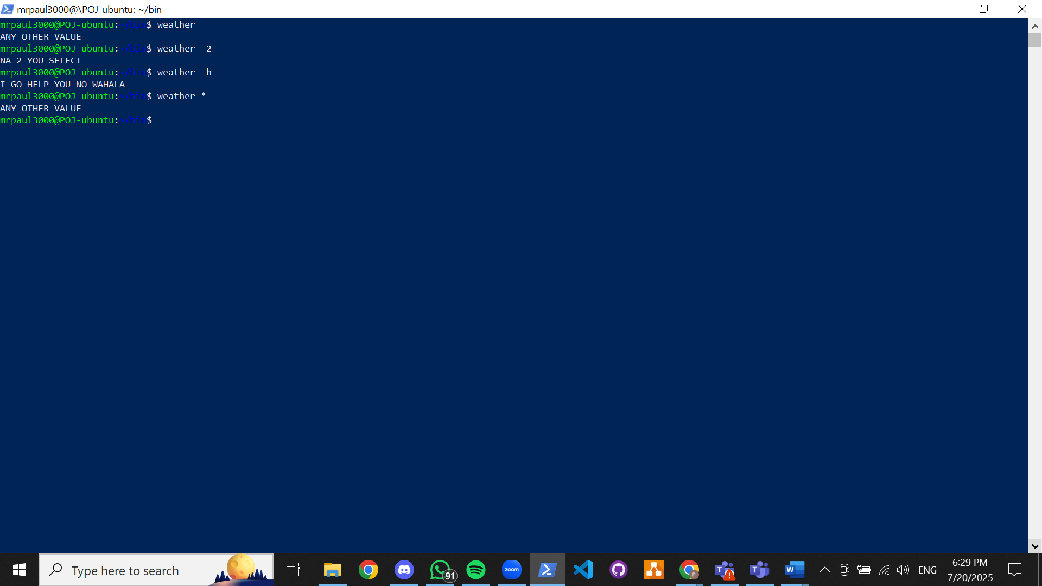

Running scripts for help command, to provide 3 days of weather report and to provide weather report for 1 day on default if anything else is run with the api command

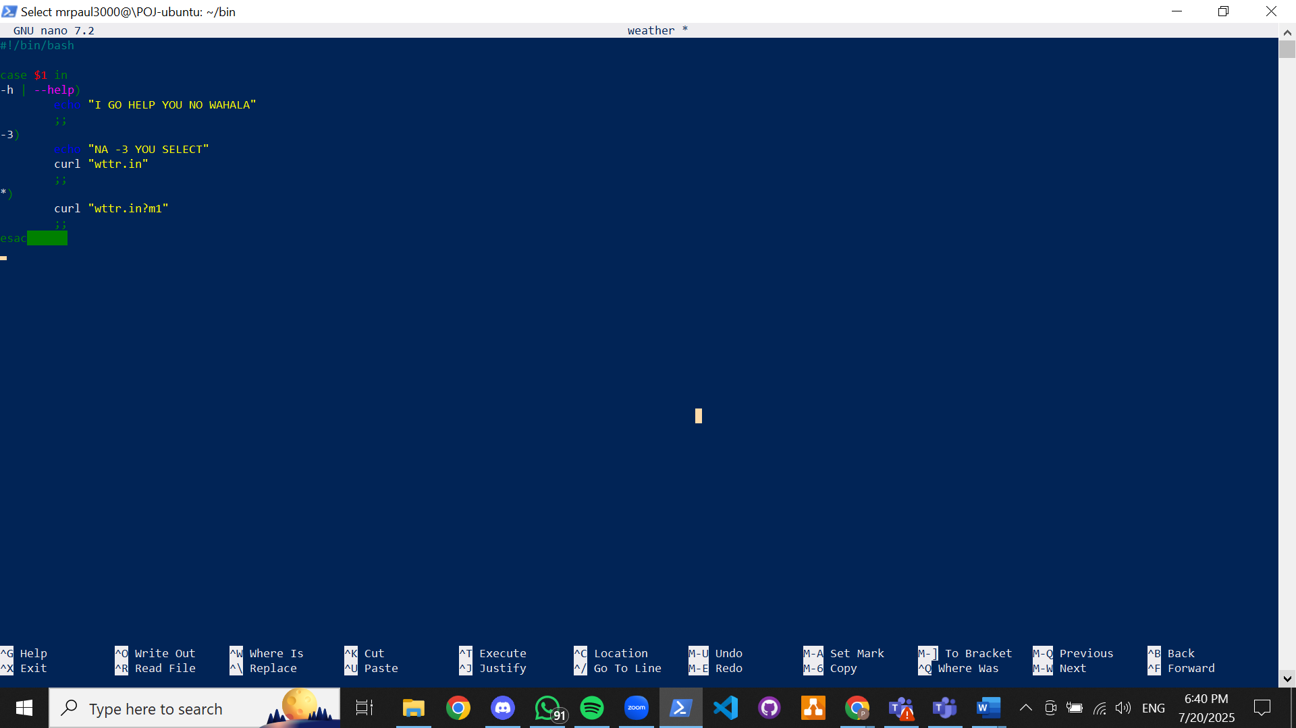

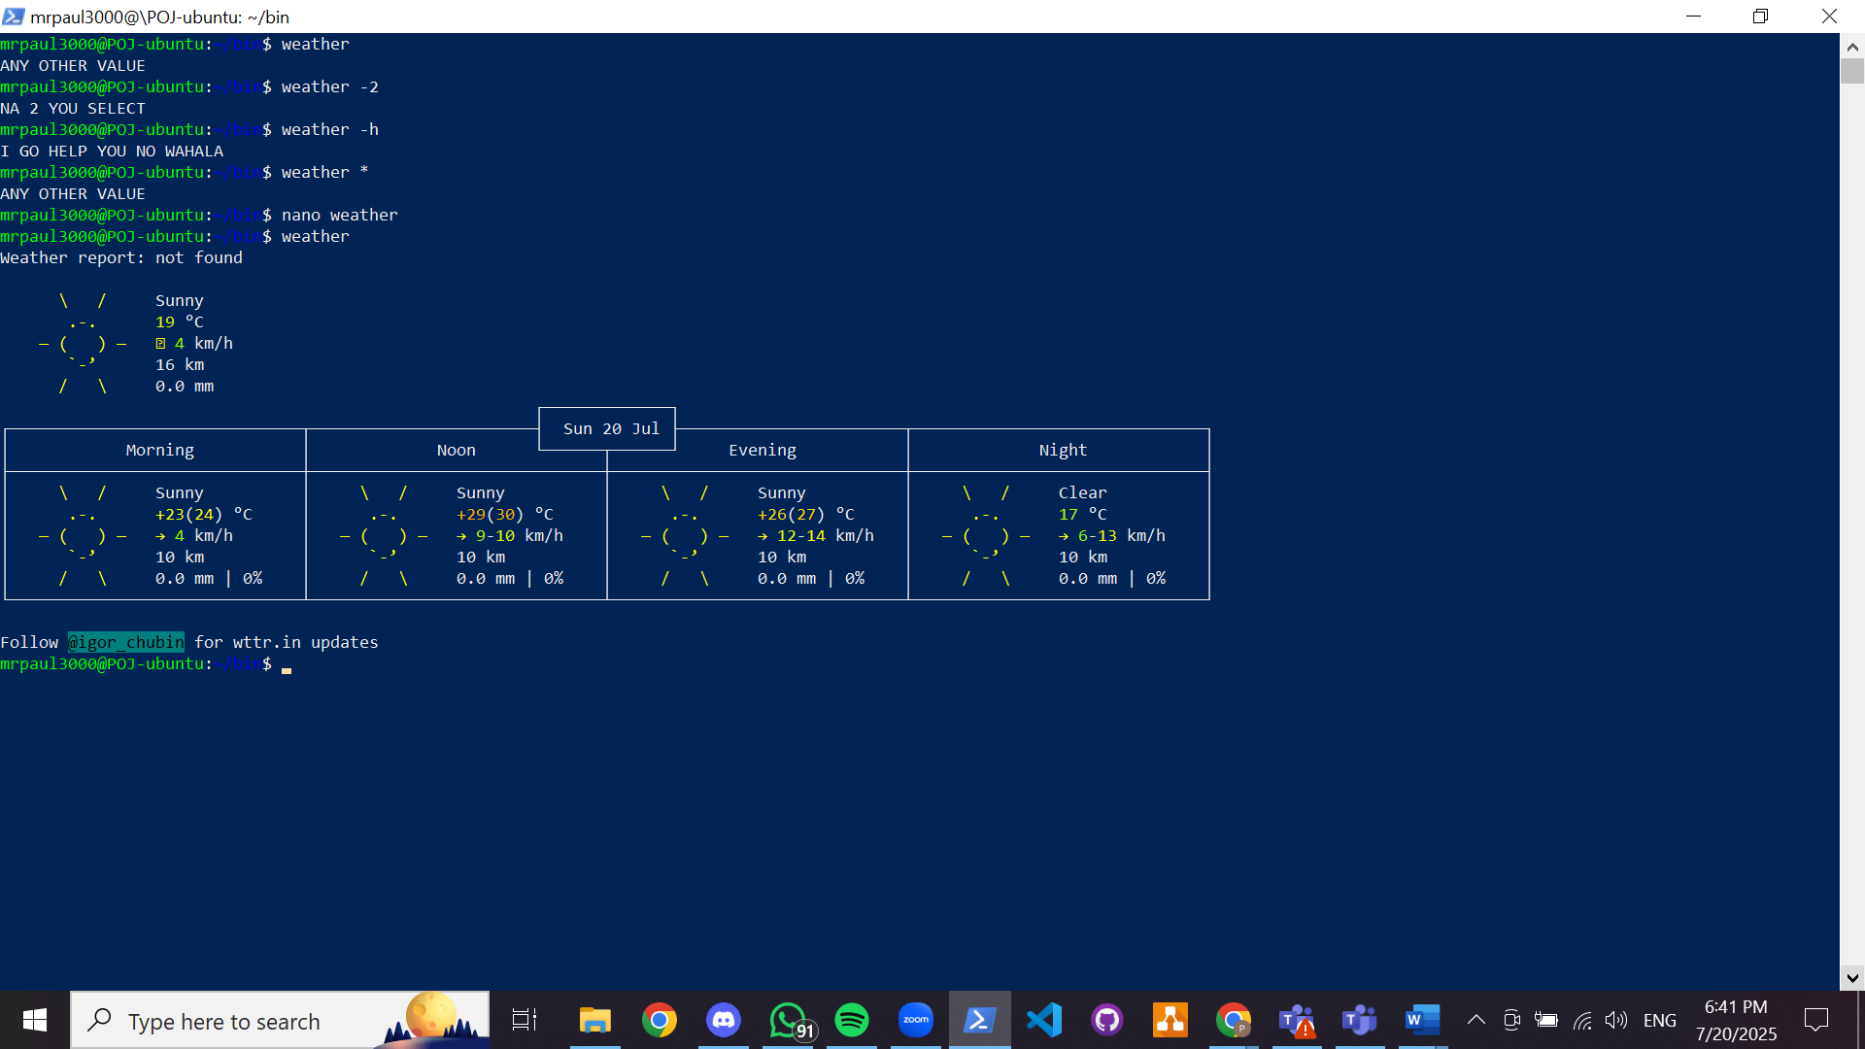

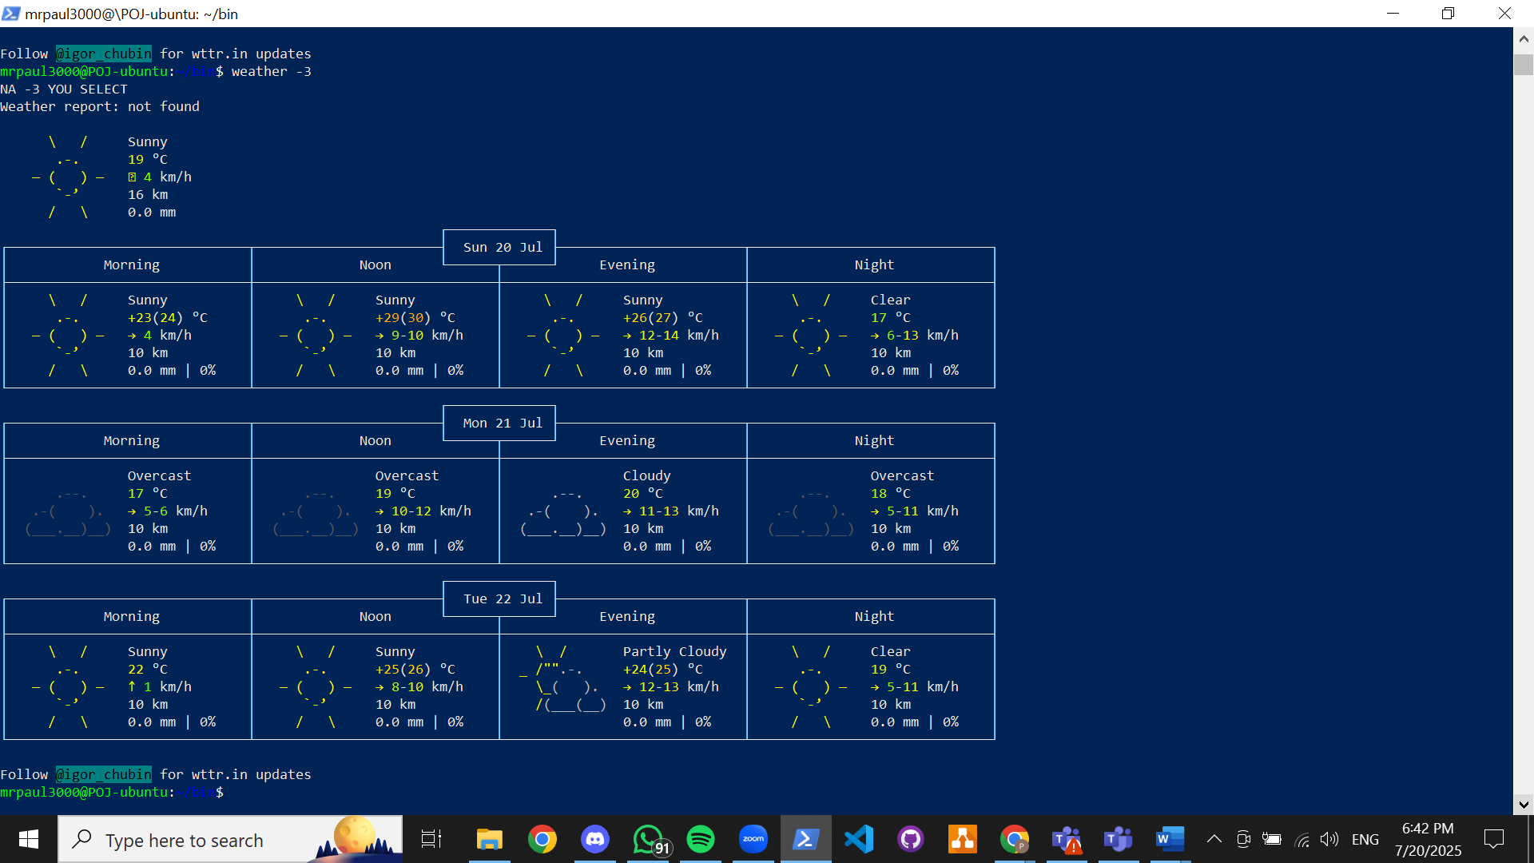

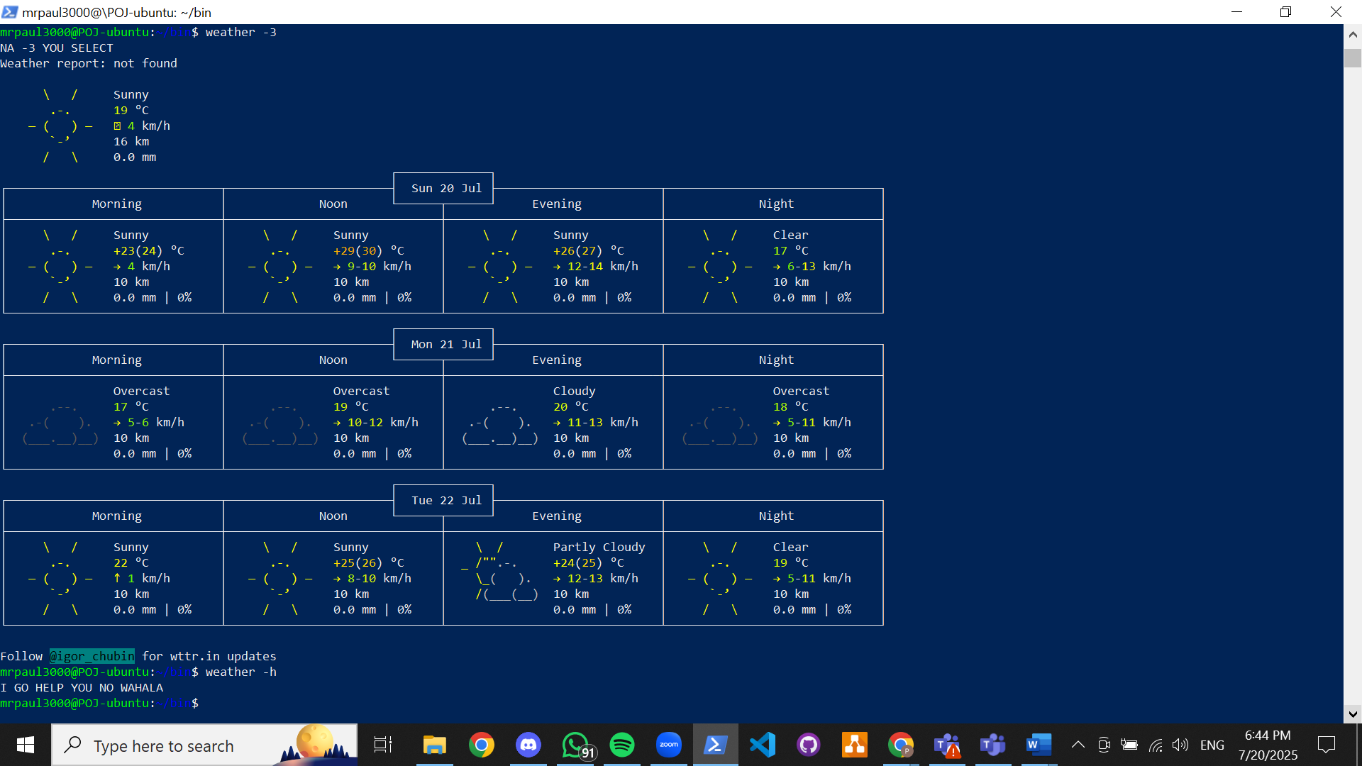

Scripting command for second value $2

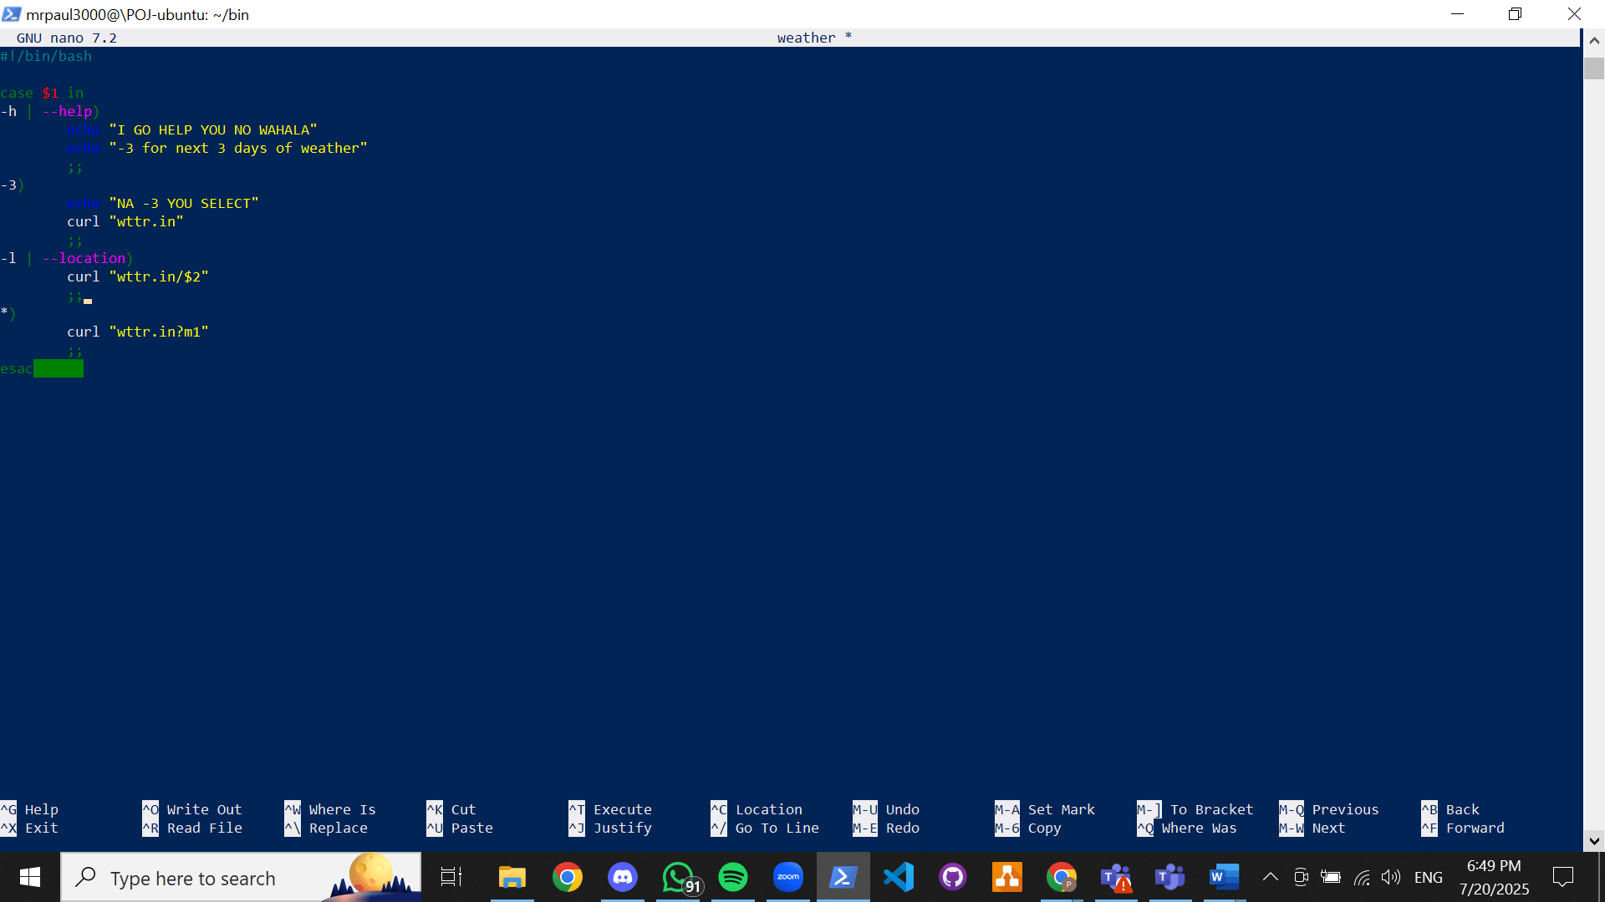

London:

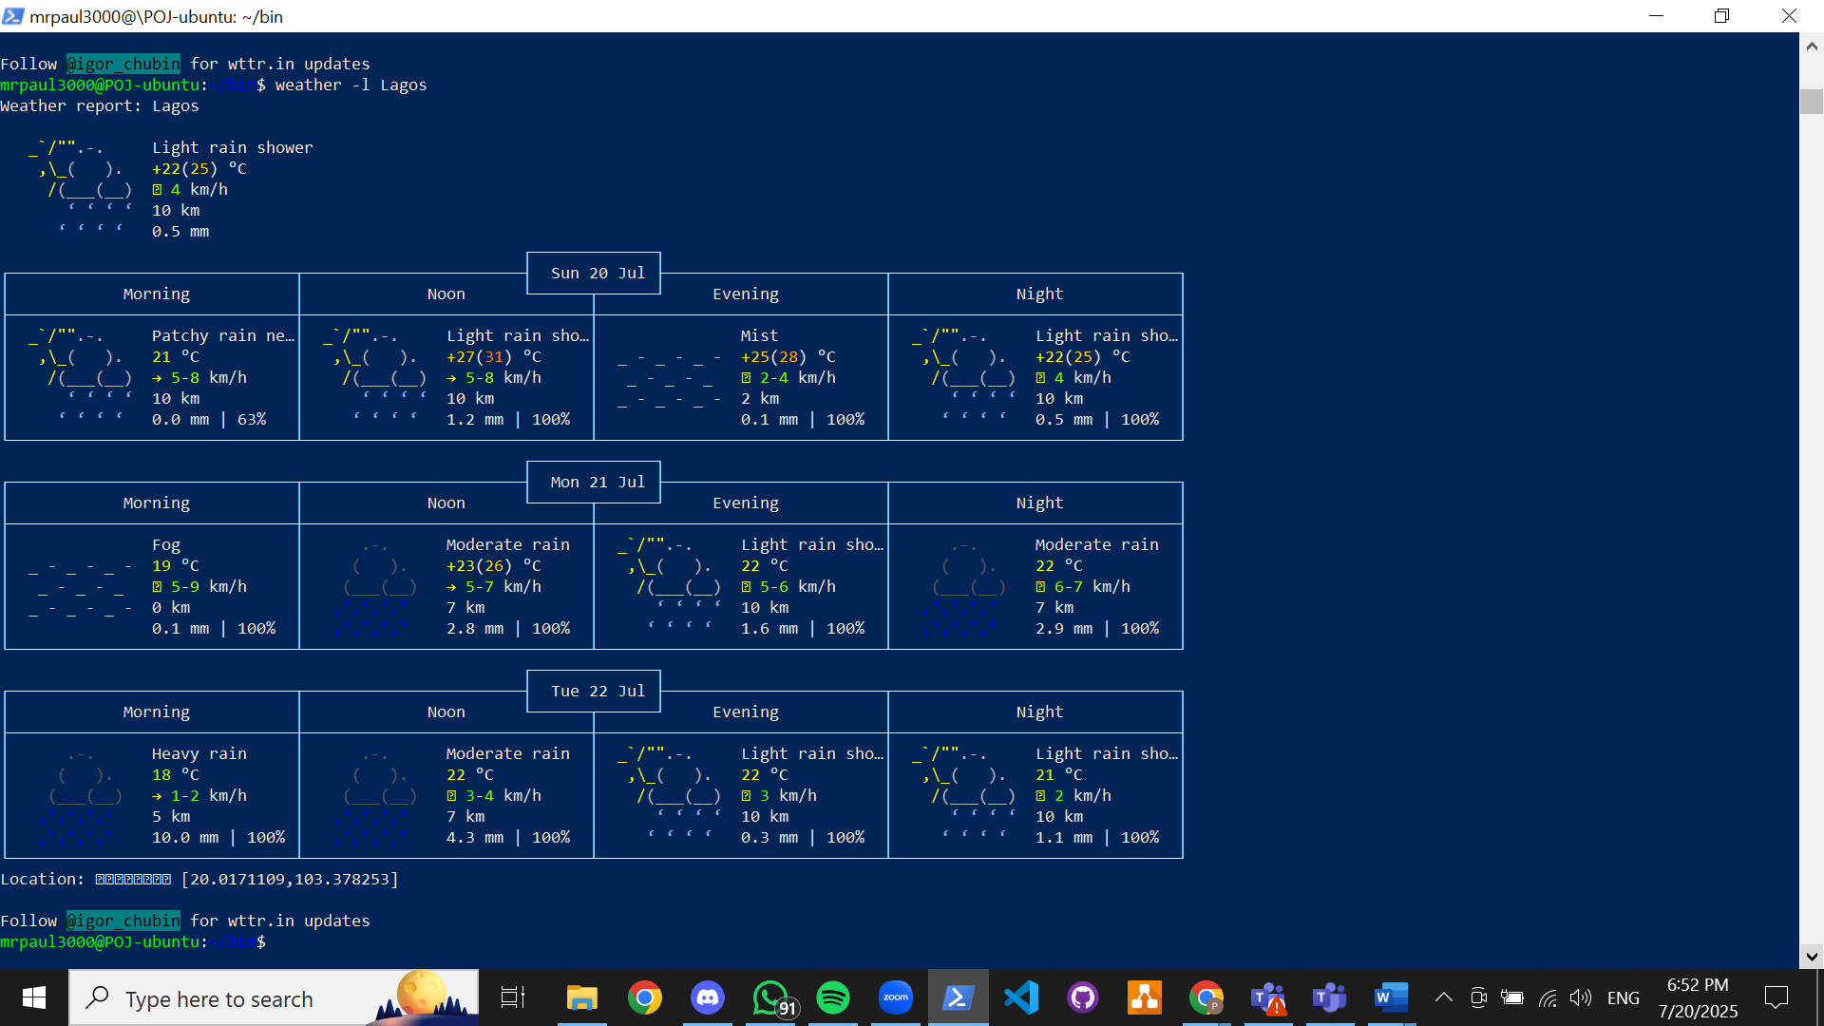

Lisbon:

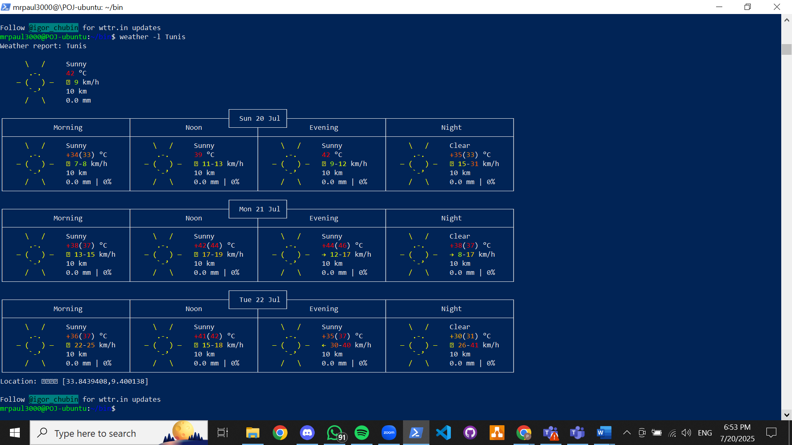

Lagos:

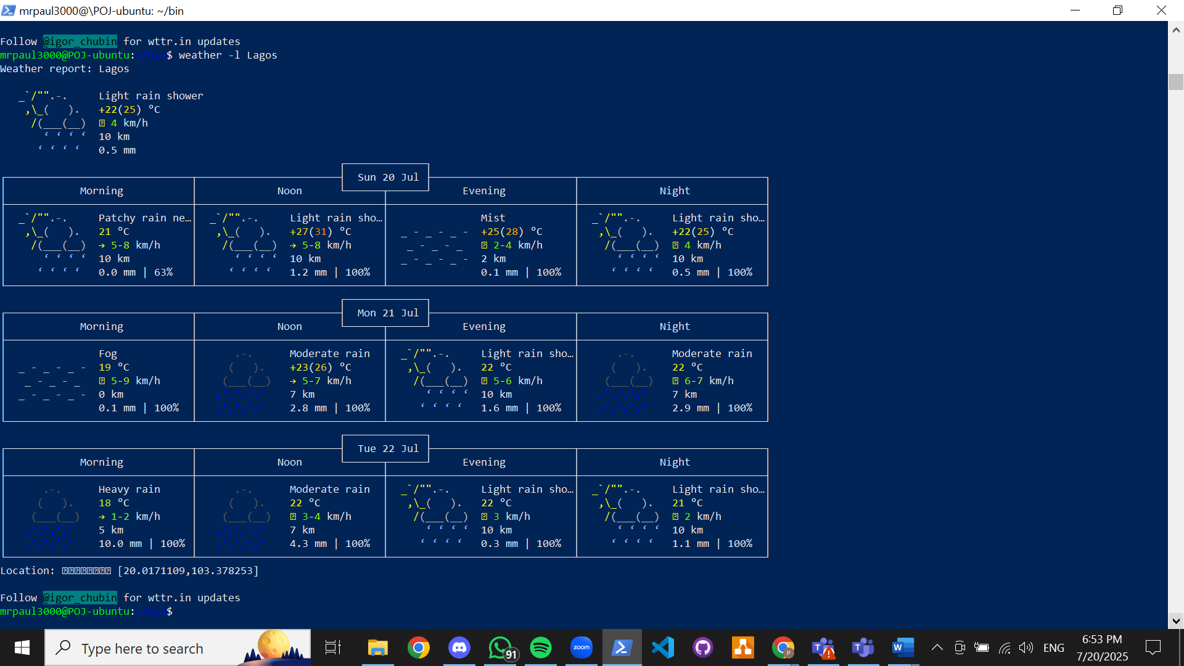

Current location:

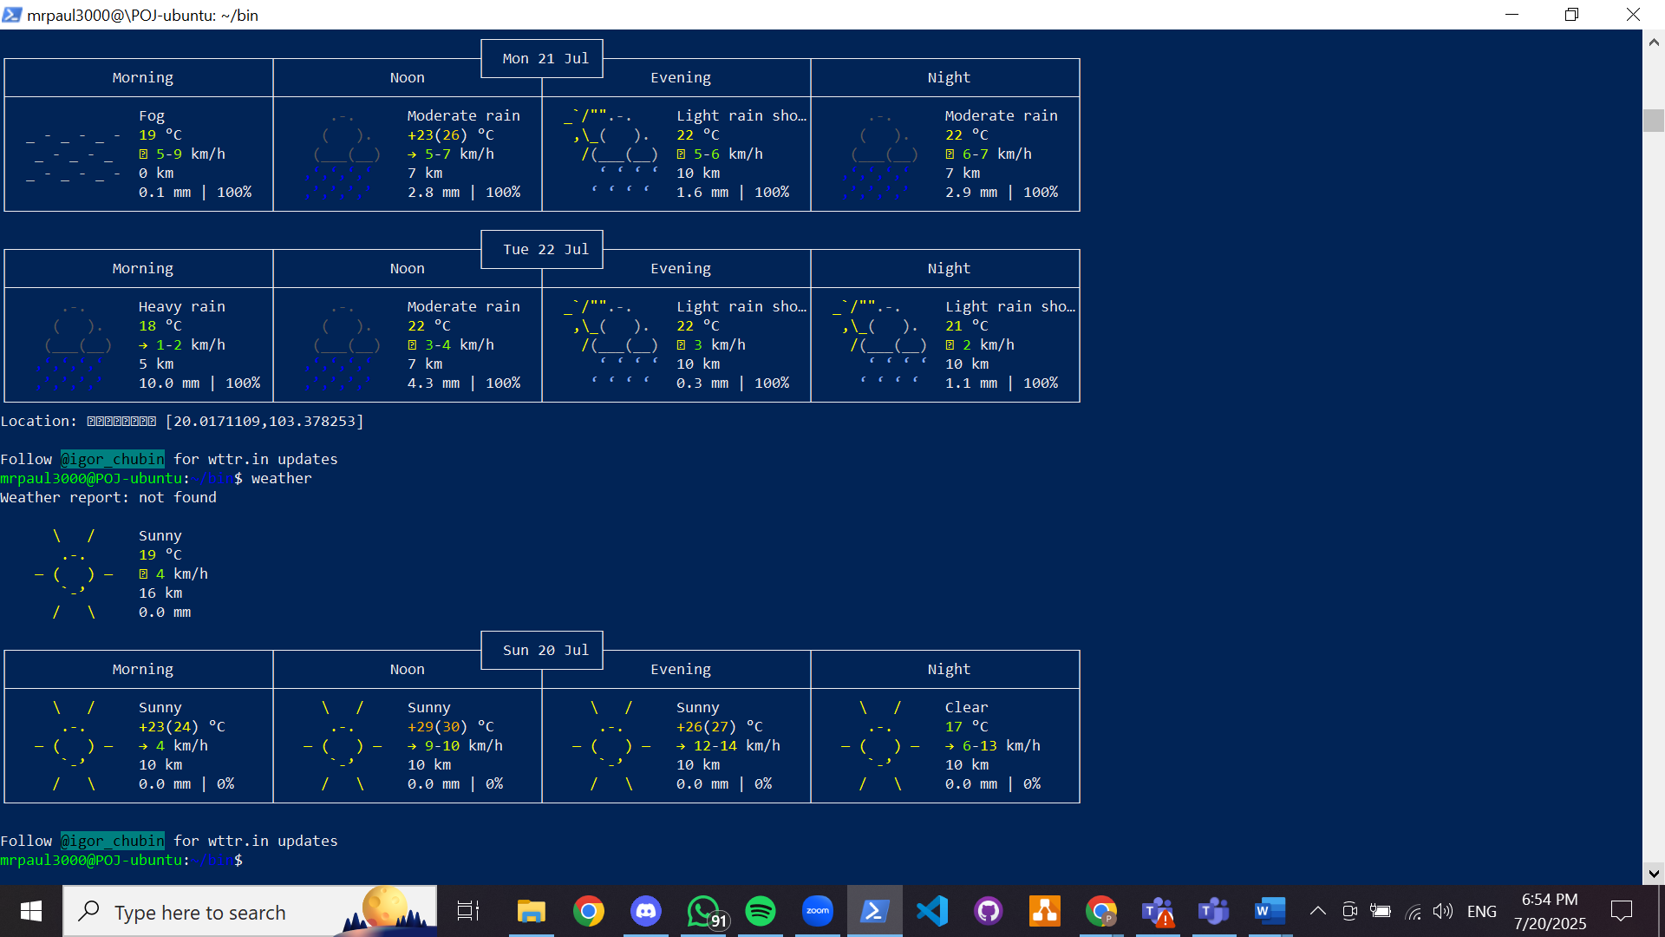

Help:

